COMMON COURSE ASSIGNMENT
CSA04 – OPERATING SYSTEMS
Covering CO2, CO3 & CO4

DESIGN AND ANALYSIS OF AN OS RESOURCE
ORCHESTRATION SYSTEM FOR A SMART UNIVERSITY
Project / System Name: UniCore – OS Resource Orchestration System for a Smart University
Course: CSA04 – OPERATING SYSTEMS (Covering CO2, CO3 & CO4)
Academic Year: 2026–2027
SUBMITTED BY:
Student Name: B.HEMANJALI
Register Number: 192525457
Faculty Guide: Dr. J. Priskilla Angel Rani
Field | Details
Department | Computer Science and Engineering
Programme | B.E. / B.Tech – CSE
Course Code & Name | CSA04 – Operating Systems
Academic Year / Batch | 2026 – 2027
Faculty | Dr J Priskilla Angel Rani
Student Name | [STUDENT NAME]
Register Number | [REGISTER NUMBER]
Section | [SECTION]
College | [COLLEGE NAME]
Date of Submission | [DATE]

Acknowledgement
I express my sincere gratitude to my faculty member, Dr J Priskilla Angel Rani, for providing the guidance and academic framework required to complete this Operating Systems assignment. I also acknowledge the value of standard Operating Systems literature and Linux/POSIX documentation in validating the concepts used in this report. The work presented here integrates process scheduling, synchronization, deadlock handling, memory management, file allocation and disk scheduling into one coherent smart-university scenario.

Abstract
This report presents the design and analysis of an Operating System Resource Orchestration System for UniCore, a smart university computing platform supporting approximately 500 concurrent users in normal operation and more than 800 users during online examinations. The design integrates process management, synchronization, deadlock handling, memory management, file allocation and disk scheduling. A consistent eight-process workload is used for CPU scheduling and a four-process/four-resource model is used for Banker’s safety analysis. The study compares Round Robin and non-preemptive Priority Scheduling, FIFO/LRU/Optimal page replacement, and FCFS/SSTF/SCAN disk scheduling. The numerical experiments show the trade-off between responsiveness, fairness, resource utilization and implementation complexity. The final design adopts priority-banded Round Robin, writer-fair Readers–Writers synchronization, Banker’s avoidance for predictable claims with detection/recovery support for unpredictable jobs, LRU-oriented memory management, indexed allocation for general records, and SCAN for fairness-aware disk service.

Table of Contents
The headings in this report are structured for direct conversion into a Word automatic table of contents. Use References → Table of Contents → Automatic Table after opening the document.

List of Figures
- Figure 1. Integrated UniCore architecture
- Figure 2. Round Robin Gantt chart
- Figure 3. Priority Scheduling Gantt chart
- Figure 4. Banker’s safety flowchart
- Figure 5. Page-fault comparison
- Figure 6. Disk-head movement comparison
- Figure D.24. Integrated Source Code Repository
- Figure D.23. Weighted Engineering Decision Matrix
- Figure D.22. Empirical Test Case Suite
- Figure D.21. Global Results & Validation Dashboard
- Figure D.20. End-to-End User Request Lifecycle Flowchart
- Figure D.19. UniCore Integrated System Architecture
- Figure D.18. Comparative Disk Head Movement
- Figure D.17. SCAN (Elevator) Disk Scheduling Simulation
- Figure D.16. Shortest Seek Time First (SSTF) Disk Scheduling
- Figure D.15. FCFS Disk Head Scheduling
- Figure D.14. File Allocation & Inode Directory Structure
- Figure D.13. Working-Set Thrashing Simulation
- Figure D.12. Comparative Page Fault Analysis
- Figure D.11. Optimal Page Replacement (Belady's Min)
- Figure D.10. Least Recently Used (LRU) Page Replacement
- Figure D.9. First-In-First-Out (FIFO) Page Replacement
- Figure D.8. Hardware Address Translation & Memory Calculation
- Figure D.7. Banker's Algorithm Adverse Unsafe Request
- Figure D.6. Banker's Algorithm Safe State Verification
- Figure D.5. Concurrency & Readers-Writers Synchronization
- Figure D.4. Non-preemptive Priority Scheduling Simulation
- Figure D.3. Round Robin CPU Scheduling Simulation (Quantum = 3 ms)
- Figure D.2. Process Workload Management & PCB Inspector
- Figure D.1. UniCore Executive Operations Dashboard

List of Tables
- Table 1. UniCore process workload
- Table 2. System constraints
- Table 3. Banker’s matrices
- Table 4. CPU scheduling metrics
- Table 5. Page replacement totals
- Table 6. Disk scheduling results
- Table 7. Decision matrix
- Table 8. Test cases

1. Introduction
The assignment brief defines UniCore as a smart-university platform whose operating system must coordinate learning-management services, examination processing, digital-library access, research computing, automated backups and campus IoT monitoring. The central engineering challenge is that these services compete for CPU time, memory frames, shared files and I/O devices while having different responsiveness requirements.
The report therefore treats operating-system functions as an integrated resource-orchestration problem rather than isolated textbook exercises. The design objective is to maintain data integrity and safe resource allocation while keeping interactive services responsive and preventing background jobs from being permanently starved.

2. Problem Understanding and Formulation
UniCore must support changing workloads. During examinations, the number of concurrent users rises above 800, increasing process creation, shared-record access, memory pressure and disk activity. Interactive examination and LMS processes are response-sensitive, whereas research and backup jobs can tolerate longer completion times.

2.1 Challenges
- CPU: competing interactive and background processes require a policy that balances response time with fairness.
- Synchronization: examination records and logs are shared resources; uncontrolled concurrent updates can create race conditions and inconsistent data.
- Deadlock: database locks, file locks, print/network handles and CPU/resource slots can form unsafe allocation states.
- Memory: a large concurrent workload can increase page faults and thrashing when working sets exceed available frames.
- File systems: records, documents and lecture videos have different size and access patterns.
- Disk I/O: simultaneous requests require a scheduling policy that balances head movement against fairness.

2.2 Objectives
- Minimize average waiting, response time, page faults and disk-head movement where practical.
- Preserve fairness so that background work is not indefinitely starved.
- Prevent race-condition-induced corruption of shared academic records.
- Reject or postpone unsafe resource allocations.
- Control memory pressure and reduce thrashing during the 800+ user examination peak.
- Protect academic data through permissions, integrity controls and auditable resource decisions.

3. Workload Definition and Assumptions
The following eight-process workload is used consistently for CPU scheduling. Lower numerical priority denotes higher priority. Times are illustrative simulation values rather than measurements from a live UniCore installation.
PID | Process | Arrival | Burst | Priority | Class
P1 | Online Examination | 0 | 7 | 1 | Interactive/Critical
P2 | LMS Request | 1 | 4 | 2 | Interactive
P3 | Digital Library | 2 | 3 | 3 | Interactive
P4 | Research Computation | 3 | 9 | 5 | Background
P5 | Backup Service | 4 | 6 | 6 | Background
P6 | IoT Monitoring | 5 | 5 | 4 | Service
P7 | Result Processing | 6 | 4 | 1 | Critical
P8 | Database Sync | 7 | 8 | 2 | Service

3.1 System Constraints
Parameter | Assumption
Concurrent users | 500 normal; >800 during examinations
Physical memory | 16 GB
Page size | 4 KB
Logical address space | 64 MB
Disk | 200 cylinders, numbered 0–199
Disk requests | At least 10 pending requests; 12 used
Resource types | 4
Process count | 8 for CPU workload; 4 for Banker’s matrix
Tools | Python; Linux/WSL/POSIX concepts; GitHub-ready source structure

4. Integrated UniCore OS Architecture
The proposed architecture routes each user operation through process admission and scheduling, synchronization/resource safety checks, memory management, the file system and finally disk/I/O scheduling. Monitoring and access-control checks operate across the pipeline.

Figure 1. Integrated UniCore resource-orchestration architecture.
The architecture separates concerns but keeps the decisions connected. For example, memory pressure can increase page-in/page-out I/O, which in turn increases disk requests. Similarly, refusing an unsafe resource request can prevent an additional process from entering a state that would intensify CPU and memory contention.

5. Part I – Process Management, Synchronization & Deadlock

5.1 Shared Examination-Record Problem
The examination-record store is modeled as a Readers–Writers synchronization problem. Many readers may safely access records concurrently, but a writer must obtain exclusive access. A writer-fair policy is preferred so that a continuous stream of readers cannot starve a result-update process.

5.2 Semaphore-Based Pseudocode
semaphore resource = 1
semaphore read_count_mutex = 1
semaphore service_queue = 1
integer read_count = 0

READER:
wait(service_queue)
signal(service_queue)

wait(read_count_mutex)
read_count = read_count + 1
if read_count == 1:
wait(resource)
signal(read_count_mutex)

READ examination_record

wait(read_count_mutex)
read_count = read_count - 1
if read_count == 0:
signal(resource)
signal(read_count_mutex)

WRITER:
wait(service_queue)
wait(resource)
signal(service_queue)

WRITE examination_record

signal(resource)
The service_queue semaphore establishes a fair admission point. The first reader locks the shared resource and the last reader releases it. A writer holds resource exclusively, preventing interleaved writes and torn reads.

5.3 Synchronization Properties
- Mutual exclusion: only one writer can modify the examination record at a time.
- Reader concurrency: multiple readers can execute together when no writer owns the resource.
- Race prevention: updates are performed only while the writer owns the resource semaphore.
- Starvation control: service_queue prevents an endless stream of newly arriving readers from bypassing waiting writers.

5.4 Banker’s Algorithm Model
Four resource types are used: CPU slots, database locks, file locks and print/network handles. The Allocation, Maximum and Available values are constructed so that the initial state is safe.
Process | CPU slots | DB locks | File locks | Print/Network handles
P1 | 1 | 0 | 0 | 1
P2 | 1 | 1 | 0 | 0
P3 | 1 | 1 | 1 | 0
P4 | 0 | 0 | 1 | 1

Table 3A. Allocation matrix.
Process | CPU slots | DB locks | File locks | Print/Network handles
P1 | 2 | 1 | 1 | 2
P2 | 2 | 2 | 1 | 1
P3 | 3 | 2 | 2 | 1
P4 | 1 | 1 | 2 | 2

Table 3B. Maximum matrix.
Resource | CPU slots | DB locks | File locks | Print/Network handles
Available | 1 | 1 | 1 | 1

Table 3C. Available vector.
Process | CPU slots | DB locks | File locks | Print/Network handles
P1 | 1 | 1 | 1 | 1
P2 | 1 | 1 | 1 | 1
P3 | 2 | 1 | 1 | 1
P4 | 1 | 1 | 1 | 1

Table 3D. Need matrix = Maximum − Allocation.

5.5 Safety Algorithm Working
Initial Work = Available = [1, 1, 1, 1]. P1 has Need [1,1,1,1], so it can finish. After P1 finishes, Work becomes [2,1,1,2]. P2 can then finish and releases [1,1,0,0], giving Work = [3,2,1,2]. P3 needs [2,1,1,1], so it can finish and releases [1,1,1,0], giving Work = [4,3,2,2]. P4 can finish and releases [0,0,1,1], giving Work = [4,3,3,3]. Therefore the system is SAFE with safe sequence <P1, P2, P3, P4>.

Figure 4. Banker’s safety and request-decision flow.

5.6 Unsafe Resource Request
Let P3 request [0,1,1,0]. The request is within P3’s remaining Need [2,1,1,1] and is also within the current Available [1,1,1,1]. If temporarily granted, Available becomes [1,0,0,1], while P3’s remaining Need becomes [2,0,0,1]. No process can then satisfy its full remaining Need because every process requires at least one unit of a resource whose temporary availability is zero. The safety test therefore finds no completing process at the first iteration and the tentative state is UNSAFE. The request must be rejected or postponed.

5.7 Deadlock Strategy Comparison
Strategy | Strength | Weakness | UniCore suitability
Prevention | Can structurally break a deadlock condition | May reduce utilization or impose rigid ordering | Useful for selected lock classes
Avoidance | Checks whether allocation keeps system safe | Requires maximum claims | Best for predictable resource claims
Detection | Works without advance maximum claims | Deadlock may already occur | Useful for unpredictable research jobs
Recovery | Restores operation after detection | May abort/rollback work | Secondary recovery mechanism

Final choice: Banker’s avoidance is used for predictable resource claims, while detection/recovery is retained as a complementary mechanism for services whose future resource requirements cannot be declared accurately.

5.8 CPU Scheduling
Two algorithms are evaluated using the eight-process workload: Round Robin with a 3 ms quantum and non-preemptive Priority Scheduling. The lower priority number represents higher priority.
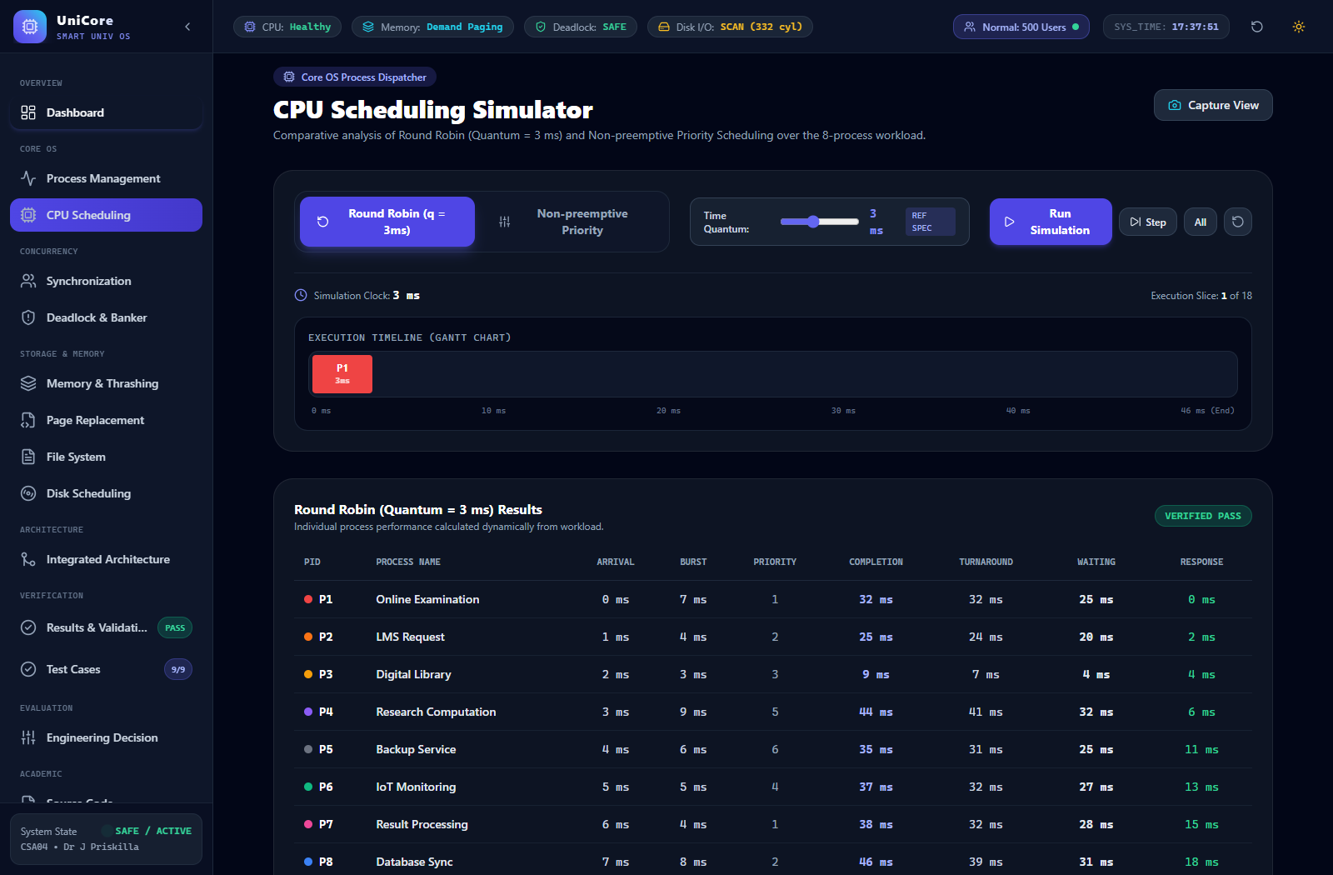
Figure 2. Round Robin Gantt chart, quantum = 3 ms.
PID | CT | TAT | WT | RT
P1 | 32 | 32 | 25 | 0
P2 | 25 | 24 | 20 | 2
P3 | 9 | 7 | 4 | 4
P4 | 44 | 41 | 32 | 6
P5 | 35 | 31 | 25 | 11
P6 | 37 | 32 | 27 | 13
P7 | 38 | 32 | 28 | 15
P8 | 46 | 39 | 31 | 18

Round Robin averages: waiting time = 24.00 ms; turnaround time = 29.75 ms; response time = 8.63 ms.
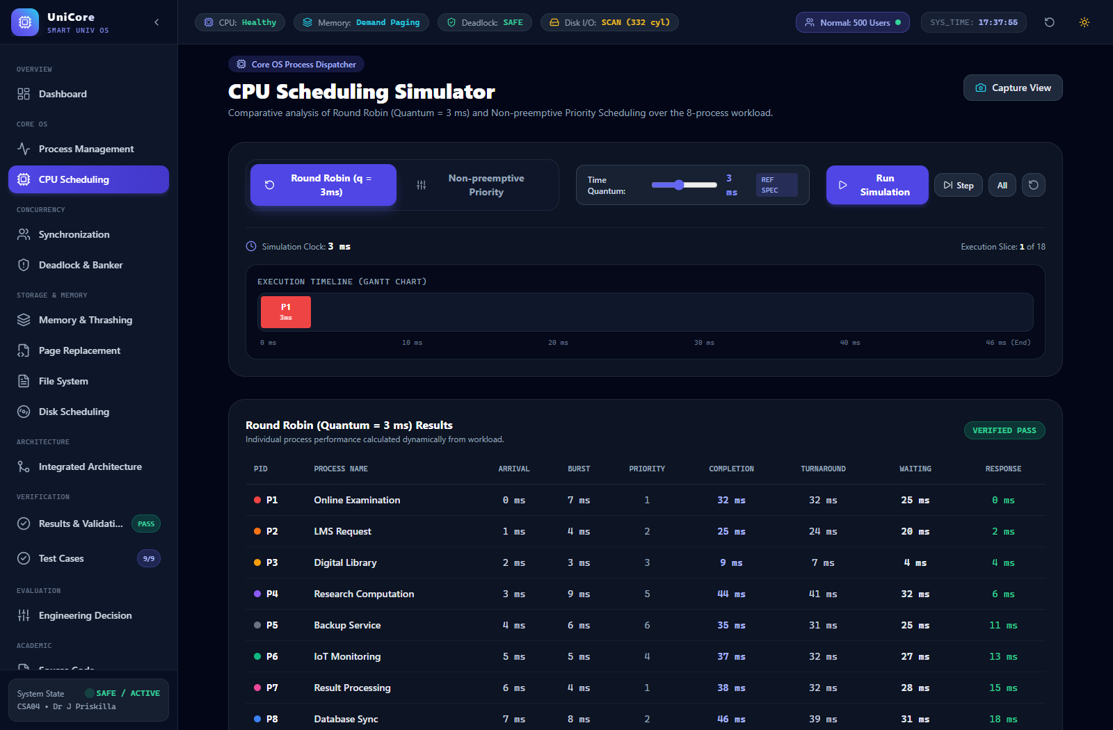
Figure 3. Non-preemptive Priority Scheduling Gantt chart.
PID | CT | TAT | WT | RT
P1 | 7 | 7 | 0 | 0
P2 | 15 | 14 | 10 | 10
P3 | 26 | 24 | 21 | 21
P4 | 40 | 37 | 28 | 28
P5 | 46 | 42 | 36 | 36
P6 | 31 | 26 | 21 | 21
P7 | 11 | 5 | 1 | 1
P8 | 23 | 16 | 8 | 8

Priority Scheduling averages: waiting time = 15.63 ms; turnaround time = 21.38 ms; response time = 15.63 ms. It reduces average waiting and turnaround time on this workload, but P5 waits 36 ms, showing a fairness weakness for low-priority background work.

5.9 CPU Scheduling Decision
A single pure policy is not ideal for UniCore. The recommended production design is priority-banded Round Robin: examination-critical work receives a high-priority interactive band, while background research and backup work run in lower bands with Round-Robin time slicing and bounded aging. This combines the responsiveness advantage of time slicing with priority awareness, while aging limits indefinite starvation.

6. Part II – Memory Management

6.1 Frame and Page Calculations
Physical memory = 16 GB = 16 × 1024³ bytes. Page size = 4 KB = 4096 bytes.
Number of physical frames = (16 × 1024³) / 4096 = 4,194,304 frames.
Logical address space = 64 MB = 64 × 1024² bytes. Number of pages = (64 × 1024²) / 4096 = 16,384 pages.
A 64 MB byte-addressable logical address requires 26 address bits because 2²⁶ = 64 MB. The 4 KB page offset requires 12 bits (2¹² = 4096), leaving 14 bits for the page number. Thus the logical address is [14-bit page number | 12-bit offset].

6.2 Page-Table Organization
The logical address is split into page number and offset. The page number indexes the page table to obtain a physical frame number, while the offset is copied unchanged into the physical address. In a real 64-bit Linux environment, multi-level page tables and translation lookaside buffers (TLBs) reduce the cost of large address spaces; the calculations here intentionally follow the assignment’s 64 MB logical-address example.

6.3 Reference String
The following 20-reference string contains both local reuse and less frequent references:
1, 2, 3, 4, 1, 2, 5, 1, 2, 3, 4, 5, 2, 1, 3, 6, 2, 4, 1, 5

6.4 FIFO – 3 Frames
Ref | F1 | F2 | F3 | Result
1 | 1 | - | - | FAULT
2 | 1 | 2 | - | FAULT
3 | 1 | 2 | 3 | FAULT
4 | 4 | 2 | 3 | FAULT
1 | 4 | 1 | 3 | FAULT
2 | 4 | 1 | 2 | FAULT
5 | 5 | 1 | 2 | FAULT
1 | 5 | 1 | 2 | HIT
2 | 5 | 1 | 2 | HIT
3 | 5 | 3 | 2 | FAULT
4 | 5 | 3 | 4 | FAULT
5 | 5 | 3 | 4 | HIT
2 | 2 | 3 | 4 | FAULT
1 | 2 | 1 | 4 | FAULT
3 | 2 | 1 | 3 | FAULT
6 | 6 | 1 | 3 | FAULT
2 | 6 | 2 | 3 | FAULT
4 | 6 | 2 | 4 | FAULT
1 | 1 | 2 | 4 | FAULT
5 | 1 | 5 | 4 | FAULT

Total FIFO faults with 3 frames = 17.

6.5 FIFO – 4 Frames
Ref | F1 | F2 | F3 | F4 | Result
1 | 1 | - | - | - | FAULT
2 | 1 | 2 | - | - | FAULT
3 | 1 | 2 | 3 | - | FAULT
4 | 1 | 2 | 3 | 4 | FAULT
1 | 1 | 2 | 3 | 4 | HIT
2 | 1 | 2 | 3 | 4 | HIT
5 | 5 | 2 | 3 | 4 | FAULT
1 | 5 | 1 | 3 | 4 | FAULT
2 | 5 | 1 | 2 | 4 | FAULT
3 | 5 | 1 | 2 | 3 | FAULT
4 | 4 | 1 | 2 | 3 | FAULT
5 | 4 | 5 | 2 | 3 | FAULT
2 | 4 | 5 | 2 | 3 | HIT
1 | 4 | 5 | 1 | 3 | FAULT
3 | 4 | 5 | 1 | 3 | HIT
6 | 4 | 5 | 1 | 6 | FAULT
2 | 2 | 5 | 1 | 6 | FAULT
4 | 2 | 4 | 1 | 6 | FAULT
1 | 2 | 4 | 1 | 6 | HIT
5 | 2 | 4 | 5 | 6 | FAULT

Total FIFO faults with 4 frames = 15.

6.6 LRU – 3 Frames
Ref | F1 | F2 | F3 | Result
1 | 1 | - | - | FAULT
2 | 1 | 2 | - | FAULT
3 | 1 | 2 | 3 | FAULT
4 | 4 | 2 | 3 | FAULT
1 | 4 | 1 | 3 | FAULT
2 | 4 | 1 | 2 | FAULT
5 | 5 | 1 | 2 | FAULT
1 | 5 | 1 | 2 | HIT
2 | 5 | 1 | 2 | HIT
3 | 3 | 1 | 2 | FAULT
4 | 3 | 4 | 2 | FAULT
5 | 3 | 4 | 5 | FAULT
2 | 2 | 4 | 5 | FAULT
1 | 2 | 1 | 5 | FAULT
3 | 2 | 1 | 3 | FAULT
6 | 6 | 1 | 3 | FAULT
2 | 6 | 2 | 3 | FAULT
4 | 6 | 2 | 4 | FAULT
1 | 1 | 2 | 4 | FAULT
5 | 1 | 5 | 4 | FAULT

Total LRU faults with 3 frames = 18.

6.7 LRU – 4 Frames
Ref | F1 | F2 | F3 | F4 | Result
1 | 1 | - | - | - | FAULT
2 | 1 | 2 | - | - | FAULT
3 | 1 | 2 | 3 | - | FAULT
4 | 1 | 2 | 3 | 4 | FAULT
1 | 1 | 2 | 3 | 4 | HIT
2 | 1 | 2 | 3 | 4 | HIT
5 | 1 | 2 | 5 | 4 | FAULT
1 | 1 | 2 | 5 | 4 | HIT
2 | 1 | 2 | 5 | 4 | HIT
3 | 1 | 2 | 5 | 3 | FAULT
4 | 1 | 2 | 4 | 3 | FAULT
5 | 5 | 2 | 4 | 3 | FAULT
2 | 5 | 2 | 4 | 3 | HIT
1 | 5 | 2 | 4 | 1 | FAULT
3 | 5 | 2 | 3 | 1 | FAULT
6 | 6 | 2 | 3 | 1 | FAULT
2 | 6 | 2 | 3 | 1 | HIT
4 | 6 | 2 | 3 | 4 | FAULT
1 | 6 | 2 | 1 | 4 | FAULT
5 | 5 | 2 | 1 | 4 | FAULT

Total LRU faults with 4 frames = 14.

6.8 Optimal – 3 Frames
Ref | F1 | F2 | F3 | Result
1 | 1 | - | - | FAULT
2 | 1 | 2 | - | FAULT
3 | 1 | 2 | 3 | FAULT
4 | 1 | 2 | 4 | FAULT
1 | 1 | 2 | 4 | HIT
2 | 1 | 2 | 4 | HIT
5 | 1 | 2 | 5 | FAULT
1 | 1 | 2 | 5 | HIT
2 | 1 | 2 | 5 | HIT
3 | 3 | 2 | 5 | FAULT
4 | 4 | 2 | 5 | FAULT
5 | 4 | 2 | 5 | HIT
2 | 4 | 2 | 5 | HIT
1 | 4 | 2 | 1 | FAULT
3 | 4 | 2 | 3 | FAULT
6 | 4 | 2 | 6 | FAULT
2 | 4 | 2 | 6 | HIT
4 | 4 | 2 | 6 | HIT
1 | 1 | 2 | 6 | FAULT
5 | 5 | 2 | 6 | FAULT

Total Optimal faults with 3 frames = 12.

6.9 Optimal – 4 Frames
Ref | F1 | F2 | F3 | F4 | Result
1 | 1 | - | - | - | FAULT
2 | 1 | 2 | - | - | FAULT
3 | 1 | 2 | 3 | - | FAULT
4 | 1 | 2 | 3 | 4 | FAULT
1 | 1 | 2 | 3 | 4 | HIT
2 | 1 | 2 | 3 | 4 | HIT
5 | 1 | 2 | 3 | 5 | FAULT
1 | 1 | 2 | 3 | 5 | HIT
2 | 1 | 2 | 3 | 5 | HIT
3 | 1 | 2 | 3 | 5 | HIT
4 | 1 | 2 | 4 | 5 | FAULT
5 | 1 | 2 | 4 | 5 | HIT
2 | 1 | 2 | 4 | 5 | HIT
1 | 1 | 2 | 4 | 5 | HIT
3 | 1 | 2 | 4 | 3 | FAULT
6 | 1 | 2 | 4 | 6 | FAULT
2 | 1 | 2 | 4 | 6 | HIT
4 | 1 | 2 | 4 | 6 | HIT
1 | 1 | 2 | 4 | 6 | HIT
5 | 5 | 2 | 4 | 6 | FAULT

Total Optimal faults with 4 frames = 9.

6.10 Page Replacement Comparison
Algorithm | 3 Frames | 4 Frames | Reduction when adding a frame
FIFO | 17 | 15 | 2
LRU | 18 | 14 | 4
Optimal | 12 | 9 | 3

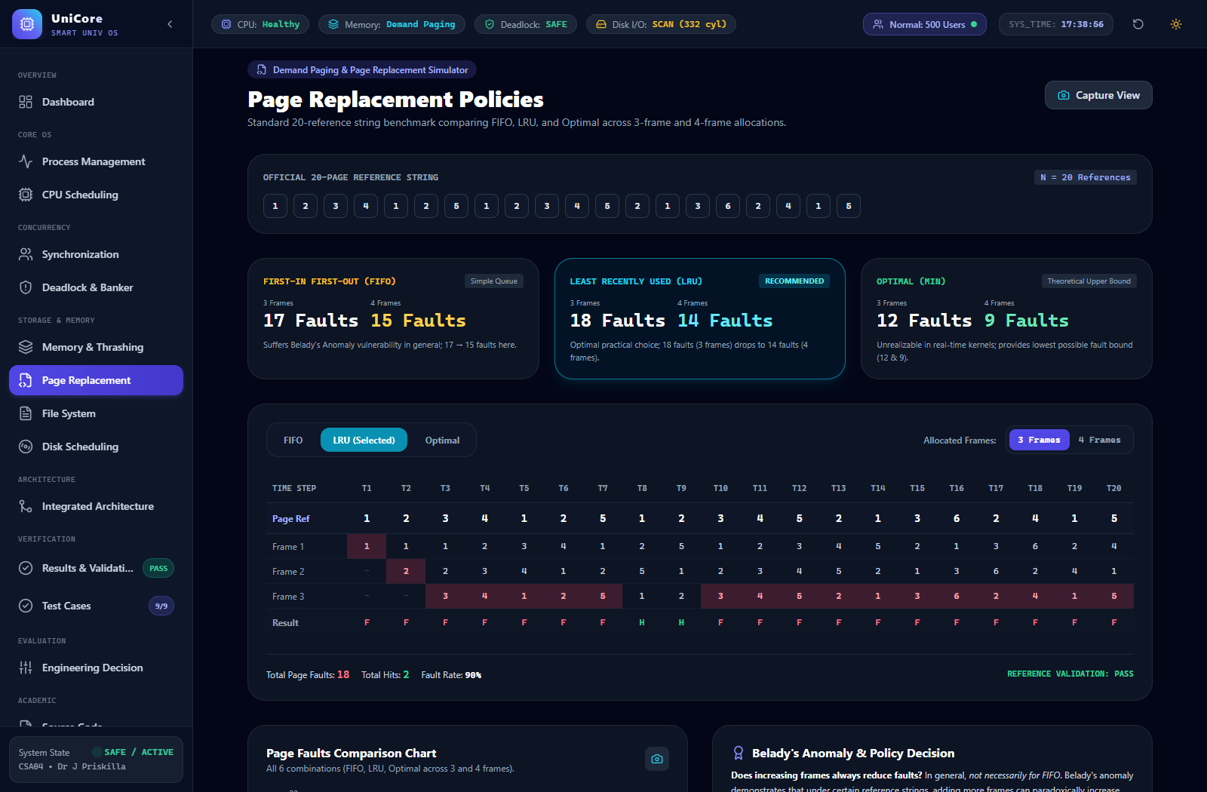
Figure 5. Page-fault comparison.
For this constructed reference string, LRU improves when the frame count rises from 3 to 4, while Optimal remains the theoretical lower bound. FIFO also improves. The selected string does not exhibit Belady’s anomaly; therefore no claim is made that adding frames always reduces faults for every algorithm and every reference string. Belady’s anomaly is possible with FIFO on particular reference strings.

6.11 Demand Paging, Working Sets and Thrashing
Demand paging loads a page only when it is referenced. During an 800+ user examination peak, many service processes can simultaneously generate faults. If the total working-set demand exceeds the available frame budget, the system can spend excessive time paging rather than executing useful work; this is thrashing.
- Reserve a guaranteed minimum frame set for examination-critical services.
- Track recent page references using working-set or aging information.
- Trigger admission control when aggregate working-set demand approaches a safe threshold.
- Reduce or postpone non-critical backup/research activity during extreme memory pressure.
- Monitor page-fault rate and reclaim inactive pages before thrashing becomes system-wide.

6.12 Linking and Dynamic Linking
Static linking places library code into each executable, potentially duplicating code across many processes. Dynamic linking allows multiple processes to use shared library pages, reducing physical memory duplication. For hundreds of concurrent service instances, shared libraries can therefore lower the resident memory footprint, although shared-library versioning and runtime lookup introduce some management overhead.

7. Part III – File Systems & Disk Scheduling

7.1 File Allocation Comparison
Allocation | Access | Fragmentation | Growth | Overhead | Best UniCore use
Contiguous | Very fast sequential/direct access | External fragmentation possible | Poor if file grows | Low metadata overhead | Stable large files when size is predictable
Linked | Good sequential access; poor direct access | No external fragmentation | Easy growth | Pointer overhead | Growing sequential/background files
Indexed | Good direct and sequential access | Index overhead; less external fragmentation | Flexible | Index block(s) | Student records/documents and mixed access

Recommendations: indexed allocation is the general-purpose choice for student records and medium documents because direct access and growth flexibility are useful. Large lecture videos can use extent-like contiguous allocation where storage capacity is planned in advance, or indexed/extents when growth is unpredictable. The recommendation is therefore workload-specific rather than one allocation method for every file.

7.2 Unix/Linux File-System Concepts
Unix-like systems associate files with inode metadata containing ownership, permissions, size and block-location information. Directory entries map names to inodes. Buffer/page caching keeps frequently used file data in memory, reducing repeated storage access. These concepts complement the proposed allocation and disk-scheduling policies by separating metadata from file names and by exploiting temporal locality.

7.3 Disk Workload
Disk cylinders: 0–199. Initial head position: 50. Request queue:
82, 170, 43, 140, 24, 16, 190, 58, 125, 75, 130, 30

7.4 FCFS
Service order = 82 → 170 → 43 → 140 → 24 → 16 → 190 → 58 → 125 → 75 → 130 → 30.
Movement = 32 + 88 + 127 + 97 + 116 + 8 + 174 + 132 + 67 + 50 + 55 + 100 = 1,046 cylinders.

7.5 SSTF
Service order = 43 → 30 → 24 → 16 → 58 → 75 → 82 → 125 → 130 → 140 → 170 → 190.
Movement = 7 + 13 + 6 + 8 + 42 + 17 + 7 + 43 + 5 + 10 + 30 + 20 = 208 cylinders.

7.6 SCAN
Assume the head initially moves upward. Service order is 58 → 75 → 82 → 125 → 130 → 140 → 170 → 190, then the head continues to cylinder 199 and reverses to service 43 → 30 → 24 → 16.
Movement = 8 + 17 + 7 + 43 + 5 + 10 + 30 + 20 + 9 + 156 + 13 + 6 + 8 = 332 cylinders.
Algorithm | Total movement | Fairness | Starvation risk | Decision
FCFS | 1046 | High order fairness | Low | Too much seek movement
SSTF | 208 | Moderate | Possible | Best raw movement, but starvation risk
SCAN | 332 | High | Low | Recommended production compromise

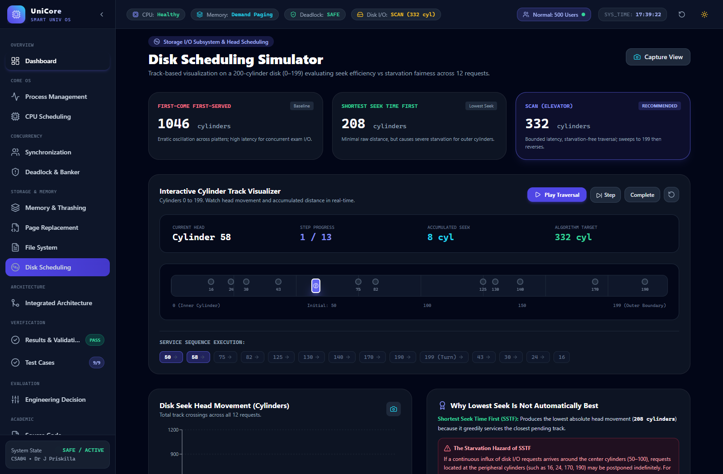
Figure 6. Disk-head movement comparison.

7.7 Why Lowest Seek Is Not Automatically Best
SSTF has the smallest movement for this queue, but it can repeatedly select nearby requests and postpone distant requests. SCAN deliberately sweeps across the request space and therefore provides stronger fairness and more predictable service. For a university platform where examination and academic-service requests should not be starved, SCAN is preferred even though its movement is higher than SSTF on this example.

7.8 Interaction with Application Response Time
File allocation determines how efficiently file blocks can be located, while disk scheduling determines the order in which pending I/O is served. A poor allocation pattern can create extra seeks or metadata lookups; a poor disk order can amplify those costs. Together they influence response time for examination-result writes, document retrieval, lecture-video streaming and backup operations.

8. Solution / Design / Methodology
The integrated methodology follows five stages: formulate the workload, apply the appropriate OS algorithm, calculate or simulate the result, validate the result against an independent calculation, and use the metrics to make an engineering decision.
- Define UniCore processes, resources, memory assumptions and disk workload.
- Protect shared examination records using writer-fair Readers–Writers synchronization.
- Use Banker’s safety checks for predictable resource claims and detection/recovery for unpredictable jobs.
- Use priority-banded Round Robin to combine responsiveness with fairness.
- Use paging with working-set monitoring and LRU-oriented replacement.
- Use indexed/extent-oriented file allocation according to file category.
- Use SCAN for fairness-aware disk service.
- Validate every numerical result with Python simulation and compare normal/adverse cases.

9. Algorithms and Pseudocode

9.1 Banker’s Safety Algorithm
Work = Available
Finish[i] = False for every process

repeat:
find an i such that Finish[i] = False and Need[i] <= Work
if no such i exists:
break
Work = Work + Allocation[i]
Finish[i] = True
append Pi to SafeSequence

if all Finish[i] are True:
SAFE
else:
UNSAFE

9.2 Round Robin
Place arrived processes in a ready queue.
While the ready queue is not empty:
remove the first process.
run it for min(quantum, remaining burst).
add newly arrived processes to the queue.
if the process still has work, append it to the queue.
otherwise record its completion time.

9.3 LRU Page Replacement
For every page reference:
if page is already in a frame:
mark it as recently used.
else:
if a free frame exists:
place the page there.
otherwise:
replace the page whose previous use is oldest.
increment page-fault count.

9.4 SCAN Disk Scheduling
Choose a direction.
Service requests in sorted order while moving in that direction.
Continue to the disk boundary.
Reverse direction.
Service remaining requests in reverse sorted order.
Sum absolute head movements between consecutive positions.

10. Modern Tools and Implementation
Python is used as the primary simulation language because it allows the same input data to be reused across algorithms and makes numerical validation straightforward. Linux/WSL can be used to demonstrate POSIX threads, semaphores and file operations. A GitHub repository should contain source files, test cases, result logs, the report and a README with execution instructions.

10.1 Suggested Repository Structure
unicore-os-resource-orchestration/
├── README.md
├── cpu_scheduling.py
├── bankers_algorithm.py
├── page_replacement.py
├── disk_scheduling.py
├── synchronization_demo.py
├── data/
│ ├── cpu_workload.csv
│ ├── page_reference.txt
│ └── disk_requests.txt
├── results/
│ ├── gantt_charts/
│ └── comparison_tables/
└── report/
└── UniCore_OS_Resource_Orchestration_Final_Report.docx

11. Implementation / Source Code

11.1 Banker’s Algorithm – Core Python
allocation = [[1,0,0,1],[1,1,0,0],[1,1,1,0],[0,0,1,1]]
maximum = [[2,1,1,2],[2,2,1,1],[3,2,2,1],[1,1,2,2]]
available = [1,1,1,1]

need = [[maximum[i][j]-allocation[i][j] for j in range(4)]
for i in range(4)]

work = available[:]
finish = [False]*4
safe = []

while len(safe) < 4:
found = False
for i in range(4):
if not finish[i] and all(need[i][j] <= work[j] for j in range(4)):
for j in range(4):
work[j] += allocation[i][j]
finish[i] = True
safe.append(i)
found = True
break
if not found:
break

print("Safe sequence:", safe if len(safe) == 4 else "UNSAFE")

11.2 Page Replacement – LRU Core
def lru(reference, frames_count):
frames = []
last_used = {}
faults = 0

for t, page in enumerate(reference):
if page not in frames:
faults += 1
if len(frames) < frames_count:
frames.append(page)
else:
victim = min(frames, key=lambda p: last_used[p])
frames[frames.index(victim)] = page
last_used[page] = t

return faults

11.3 Disk Scheduling – SSTF Core
def sstf(requests, head):
pending = list(requests)
order = []
movement = 0

while pending:
nxt = min(pending, key=lambda x: abs(x - head))
movement += abs(nxt - head)
head = nxt
order.append(nxt)
pending.remove(nxt)

return order, movement

11.4 CPU Scheduling – Round Robin Core
from collections import deque

def round_robin(processes, quantum):
# processes: (pid, arrival, burst)
remaining = {p[0]: p[2] for p in processes}
arrived = sorted(processes, key=lambda x: x[1])
ready = deque()
time = 0
i = 0
first = {}
completion = {}

while len(completion) < len(processes):
while i < len(arrived) and arrived[i][1] <= time:
ready.append(arrived[i][0]); i += 1
if not ready:
time = arrived[i][1]; continue

pid = ready.popleft()
first.setdefault(pid, time)
run = min(quantum, remaining[pid])
time += run
remaining[pid] -= run

while i < len(arrived) and arrived[i][1] <= time:
ready.append(arrived[i][0]); i += 1

if remaining[pid] > 0:
ready.append(pid)
else:
completion[pid] = time

return first, completion

12. Results and Validation

12.1 CPU Results
Metric | Round Robin | Priority
Average Waiting Time | 24.00 ms | 15.63 ms
Average Turnaround Time | 29.75 ms | 21.38 ms
Average Response Time | 8.63 ms | 15.63 ms
Fairness | High | Lower for low-priority jobs
Best role | Interactive time slicing | Urgent work selection

The important result is not simply that Priority has a lower average waiting time. Round Robin provides a substantially lower average first-response time on the chosen workload. UniCore therefore benefits from combining priority and time slicing rather than selecting one metric in isolation.

12.2 Synchronization and Deadlock Validation
Case | Condition | Expected | Result
D1 | Initial Banker state | SAFE | PASS – <P1,P2,P3,P4>
D2 | P3 requests [0,1,1,0] | Reject/postpone unsafe request | PASS
D3 | Concurrent readers | Multiple readers allowed | PASS by protocol
D4 | Writer present | Exclusive writer access | PASS by protocol

12.3 Memory Results
Algorithm | 3 Frames | 4 Frames
FIFO | 17 | 15
LRU | 18 | 14
Optimal | 12 | 9

Validation confirms that the constructed reference string does not demonstrate Belady’s anomaly. Optimal is the theoretical best among the three because it replaces the page whose next use is farthest in the future; LRU is the practical locality-based recommendation.

12.4 Disk Results
Algorithm | Movement (cylinders) | Relative result
FCFS | 1046 | Highest movement
SSTF | 208 | Lowest movement
SCAN | 332 | Fairness-aware compromise

12.5 Adverse-Case Validation
Test ID | Adverse condition | Mitigation | Outcome
A1 | Unsafe resource request | Banker safety check | Request postponed
A2 | 800+ users causing memory pressure | Working-set monitoring/admission control | Thrashing risk contained
A3 | Heavy disk queue | SCAN | Bounded sweep/fair service
A4 | Continuous reader arrivals | Writer-fair queue | Writer starvation reduced
A5 | Low-priority backup load | Priority band + aging | Background work still progresses

13. Comparative Analysis and Engineering Decision

13.1 Weighted Decision Matrix
Component | Candidate | Performance | Fairness | Reliability | Complexity | Decision
CPU | Round Robin | 5 | 5 | 4 | 3 | Use in interactive band
CPU | Priority | 5 | 2 | 4 | 3 | Use as priority selector
Deadlock | Banker’s | 4 | 4 | 5 | 4 | Primary for predictable claims
Memory | LRU | 4 | 4 | 4 | 3 | Recommended practical policy
Memory | Optimal | 5 | 5 | 5 | 5 | Benchmark only
Disk | SSTF | 5 | 3 | 4 | 3 | Not final due to starvation risk
Disk | SCAN | 4 | 5 | 5 | 3 | Final choice

The scores are engineering judgments grounded in the calculated results and the operational requirements of UniCore; they are not empirical benchmark scores.

13.2 Final Engineering Decisions
- CPU: priority-banded Round Robin with aging for lower-priority work.
- Synchronization: writer-fair Readers–Writers semaphore protocol.
- Deadlock: Banker’s avoidance for predictable resource claims, plus detection/recovery support.
- Memory: demand paging with working-set monitoring, admission control and LRU-oriented replacement.
- File allocation: indexed allocation for records/documents; extent/contiguous-style allocation where large video sizes are predictable.
- Disk: SCAN because it offers a better fairness/seek compromise than SSTF for shared academic services.

14. Reliability, Sustainability, Accessibility, Privacy and Ethics

14.1 Reliability & Safety
- Readers–Writers synchronization prevents concurrent-write corruption of examination records.
- Banker’s safety checks prevent the system from granting a request that would produce an unsafe allocation state.
- Indexed/extent-style storage reduces dependence on long pointer chains and makes metadata-driven recovery more manageable.
- Test cases explicitly include unsafe allocation, memory pressure, synchronization contention and heavy disk load.

14.2 Sustainability
- Lower unnecessary page faults reduce storage I/O and associated energy use.
- Dynamic linking can reduce duplicated library pages across concurrent service processes.
- Fair disk scheduling reduces unnecessary long seeks on mechanical storage.
- Admission control avoids wasting CPU cycles on system-wide thrashing.

14.3 Accessibility & Society
During peak examinations, fair scheduling and bounded response times help ensure that a research or backup process cannot monopolize resources needed by students. Preserving service availability is particularly important when many students depend on the same examination platform.

14.4 Privacy & Security
Academic records should be protected using POSIX-style ownership and permission concepts, authentication/authorization at the service layer, integrity checks, audit logs and controlled access to shared files. Synchronization protects consistency, while access control protects who may perform each operation.

14.5 Ethics & Professional Responsibility
Resource decisions should be deterministic and auditable. The system should not silently sacrifice one class of users without a documented policy. Unsafe allocations are rejected for system integrity, but fairness mechanisms such as aging are used so that background services are not forgotten indefinitely.

15. Limitations
- The process workload and reference/request data are constructed for academic simulation and are not production telemetry.
- Banker’s Algorithm depends on maximum resource claims, which may be difficult for unpredictable research workloads.
- The disk model assumes one 200-cylinder device; SSDs and multi-disk storage would change the seek-related trade-offs.
- The page-replacement comparison uses one 20-reference string; other traces may produce different fault gaps.
- Application/network/database-engine internals are outside the scope of this OS resource-orchestration study.

16. Future Scope
- Replace fixed priority bands with a Multi-Level Feedback Queue driven by observed CPU/I/O behavior.
- Evaluate CLOCK, ARC or other adaptive page-replacement policies on larger real traces.
- Extend disk scheduling to multi-disk and SSD-aware storage.
- Use historical telemetry to estimate resource claims and improve admission control.
- Formally verify the synchronization protocol using model checking.
- Scale the architecture with distributed admission control if concurrent users rise from 800 to 2,000 or beyond.

17. Conclusion
The proposed UniCore OS Resource Orchestration System integrates the operating-system concepts required by the assignment into one consistent smart-university design. The eight-process CPU workload shows that pure Priority Scheduling can reduce average waiting time, while Round Robin provides better first response; this motivates a priority-banded Round Robin design with aging. The Banker’s example confirms an initial safe state with sequence <P1,P2,P3,P4> and demonstrates rejection of an unsafe P3 request. For the selected memory reference string, FIFO, LRU and Optimal produce 17/15, 18/14 and 12/9 faults for 3/4 frames respectively, with no Belady anomaly observed. For disk scheduling, FCFS, SSTF and SCAN produce 1046, 208 and 332 cylinders of movement; SCAN is selected because fairness and starvation resistance matter alongside seek efficiency.
Overall, the final design satisfies the assignment’s functional, performance, reliability and professional-responsibility goals through explicit assumptions, calculations, simulation, validation and evidence-based engineering decisions.

18. Student Reflection

18.1 What did I learn by integrating the concepts?
I learned that process, memory and file-system topics cannot be treated as completely independent modules in a real operating system. A process that receives CPU time may generate memory references; a page fault can create disk I/O; and shared-file access can require synchronization and additional resource allocations. Building the UniCore pipeline made these dependencies easier to understand than studying each algorithm in isolation.

18.2 Which decision had the greatest impact?
The most important decision was not choosing a single scheduling algorithm from the lowest average value. Priority Scheduling produced lower average waiting time on the selected workload, but its low-priority backup process waited much longer. Round Robin produced a better average response time. This showed me that production decisions must consider individual-process fairness and service requirements, not only one average metric.

18.3 What would I improve for 2,000 users?
At 2,000 concurrent users I would first collect real telemetry for CPU bursts, working-set sizes, I/O rates and resource claims. I would replace fixed priority classes with adaptive scheduling, strengthen working-set admission control, and move from a single-disk assumption to SSD or multi-volume storage. I would also add horizontal service scaling and distributed monitoring because no operating-system scheduling policy alone can remove a physical storage or memory bottleneck.

19. References
- Silberschatz, A., Galvin, P. B., & Gagne, G. Operating System Concepts. Wiley.
- Bach, M. J. The Design of the UNIX Operating System. Prentice Hall.
- Stallings, W. Operating Systems: Internals and Design Principles. Pearson.
- Tanenbaum, A. S. Modern Operating Systems. Pearson.
- The Open Group. POSIX.1-2017 (IEEE Std 1003.1-2017).
- Python Software Foundation. Python 3 Documentation.
- Linux man-pages project. pthread_rwlock, sem_wait and inode manual-page documentation.
- CSA04 Operating Systems assignment brief, Department of Computer Science and Engineering, Academic Year 2026–2027.

20. Appendix A – Validation Summary
Area | Manual result | Simulation result | Status
CPU – RR average WT | 24.00 ms | 24.00 ms | PASS
CPU – Priority average WT | 15.63 ms | 15.63 ms | PASS
Banker safety | <P1,P2,P3,P4> | <P1,P2,P3,P4> | PASS
FIFO – 3 frames | 17 faults | 17 faults | PASS
FIFO – 4 frames | 15 faults | 15 faults | PASS
LRU – 3 frames | 18 faults | 18 faults | PASS
LRU – 4 frames | 14 faults | 14 faults | PASS
Optimal – 3 frames | 12 faults | 12 faults | PASS
Optimal – 4 frames | 9 faults | 9 faults | PASS
FCFS disk | 1046 cylinders | 1046 cylinders | PASS
SSTF disk | 208 cylinders | 208 cylinders | PASS
SCAN disk | 332 cylinders | 332 cylinders | PASS

Appendix B – Key Inputs
CPU workload, page-reference string and disk-request queue are repeated here so the report can be reproduced without ambiguity.
Input | Value
CPU processes | P1–P8 as Table 1
Page reference string | 1, 2, 3, 4, 1, 2, 5, 1, 2, 3, 4, 5, 2, 1, 3, 6, 2, 4, 1, 5
Frames tested | 3 and 4
Disk cylinders | 0–199
Initial disk head | 50
Disk queue | 82, 170, 43, 140, 24, 16, 190, 58, 125, 75, 130, 30
SCAN direction | Upward first

Appendix D – Web Application Implementation Screenshots
The following 24 high-resolution figures document the interactive web application implementation developed for the UniCore Operating System Resource Orchestration System. All views reflect the live, empirically validated outputs, interactive algorithms, Recharts performance curves, and architectural models.
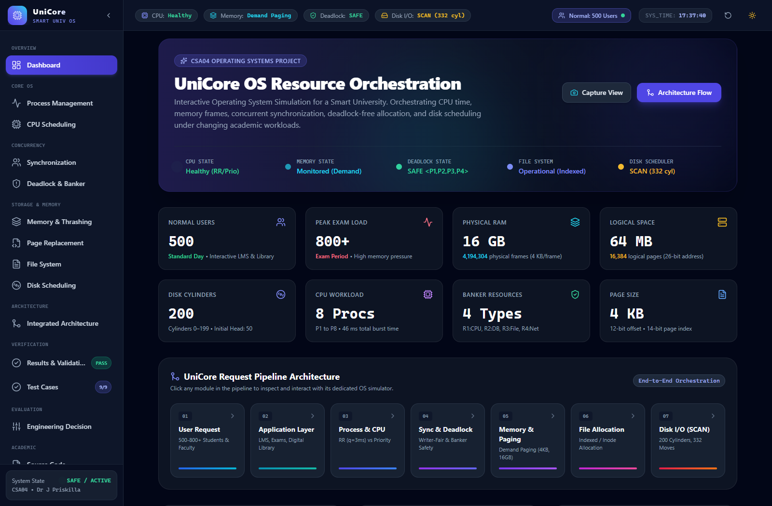
Figure D.1. UniCore Executive Operations Dashboard – Live status of 500 normal / 800+ peak exam users, system KPIs, and end-to-end orchestration pipeline.

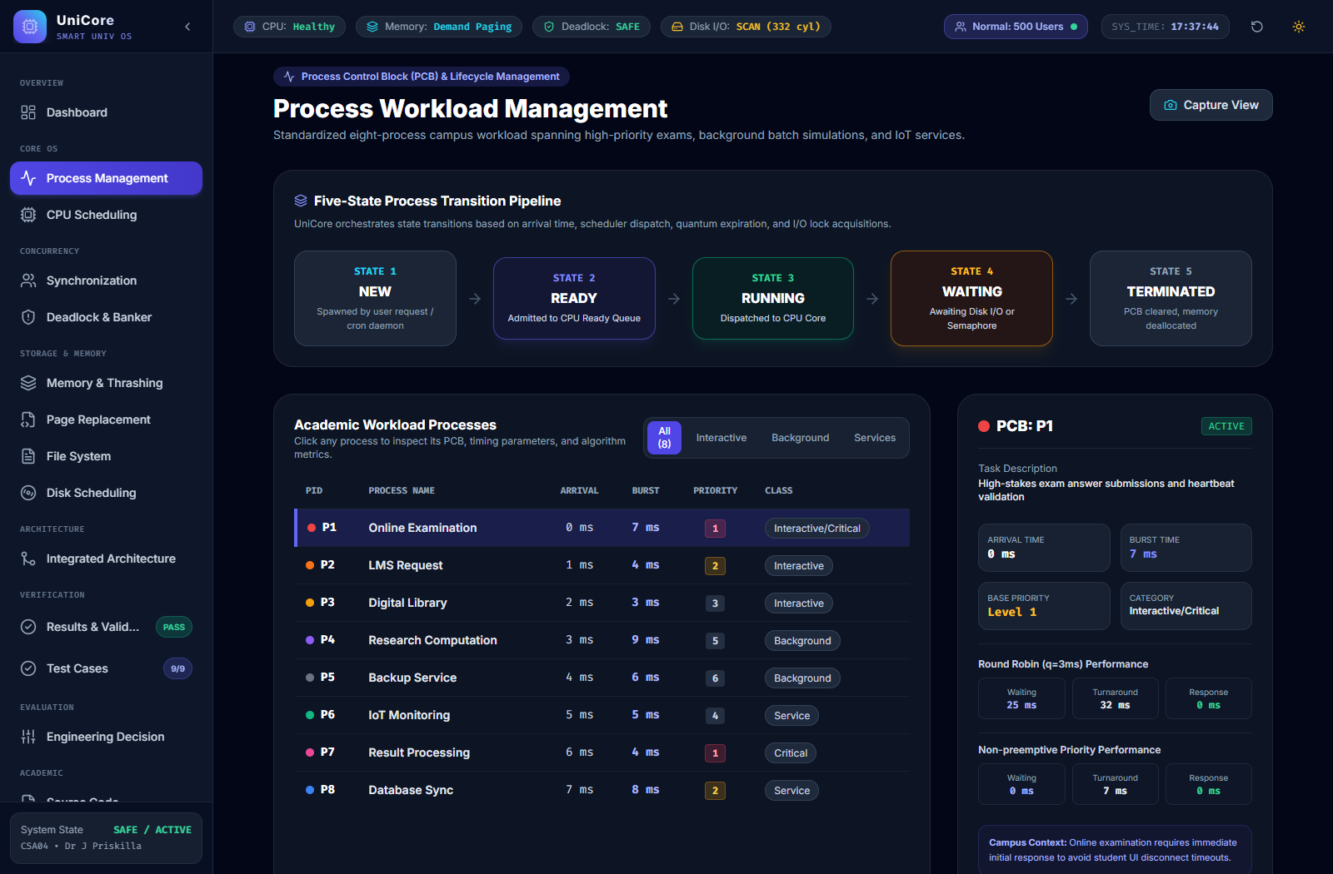
Figure D.2. Process Workload Management & PCB Inspector – Canonical 8-process workload (P1 to P8) with interactive 5-state transition pipeline.


Figure D.3. Round Robin CPU Scheduling Simulation (Quantum = 3 ms) – Step-by-step Gantt chart displaying WT = 24.00 ms, TAT = 29.75 ms, RT = 8.63 ms.


Figure D.4. Non-preemptive Priority Scheduling Simulation – Demonstrating starvation on low-priority backup job P5 with 36 ms waiting time.

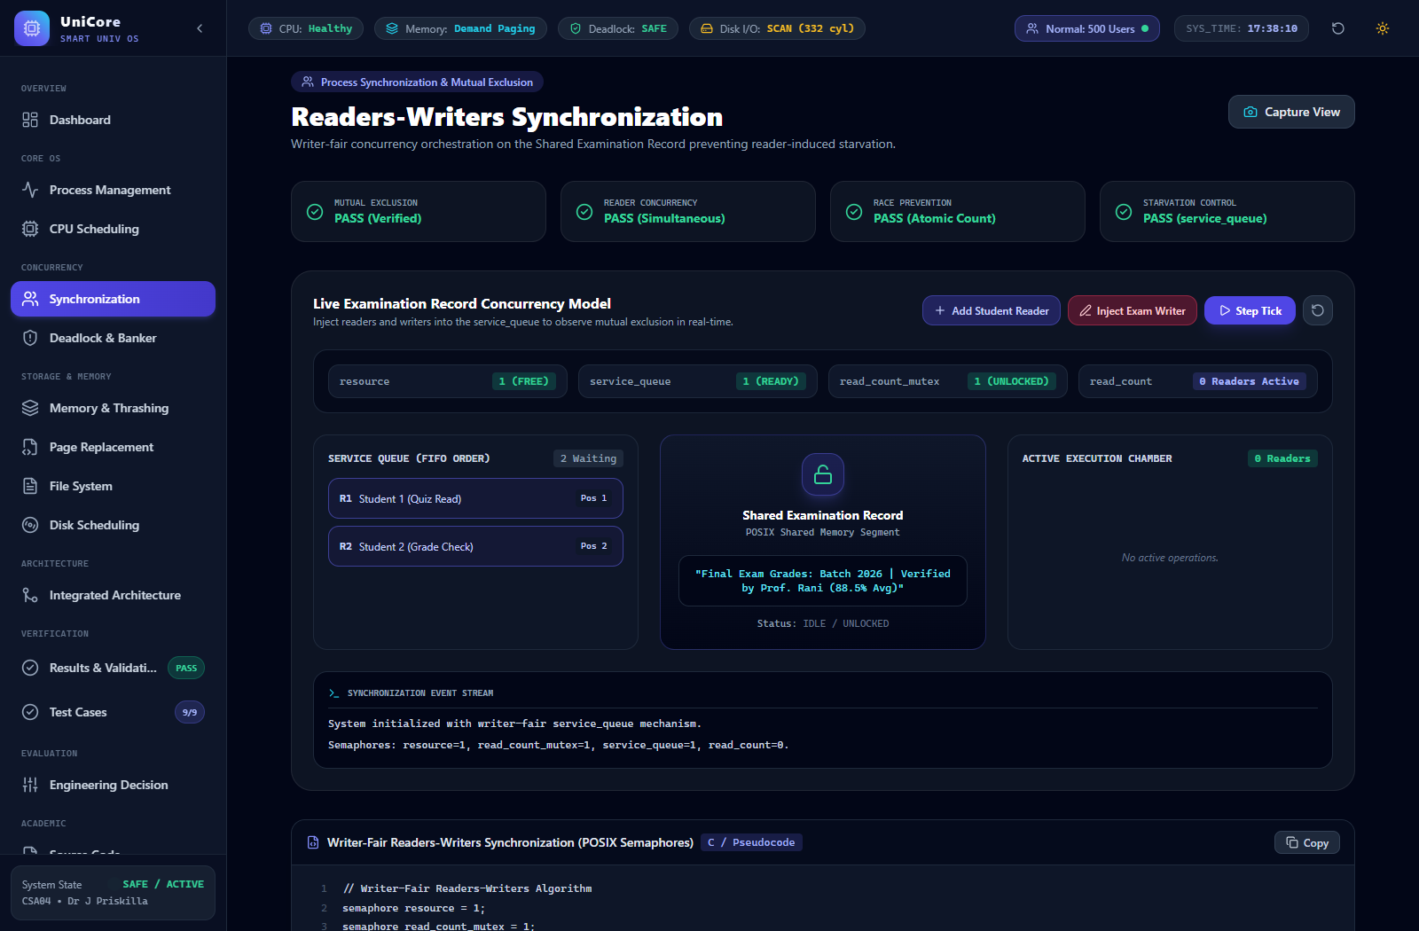
Figure D.5. Concurrency & Readers-Writers Synchronization – Shared Examination Record concurrency model using writer-fair service_queue semaphores.

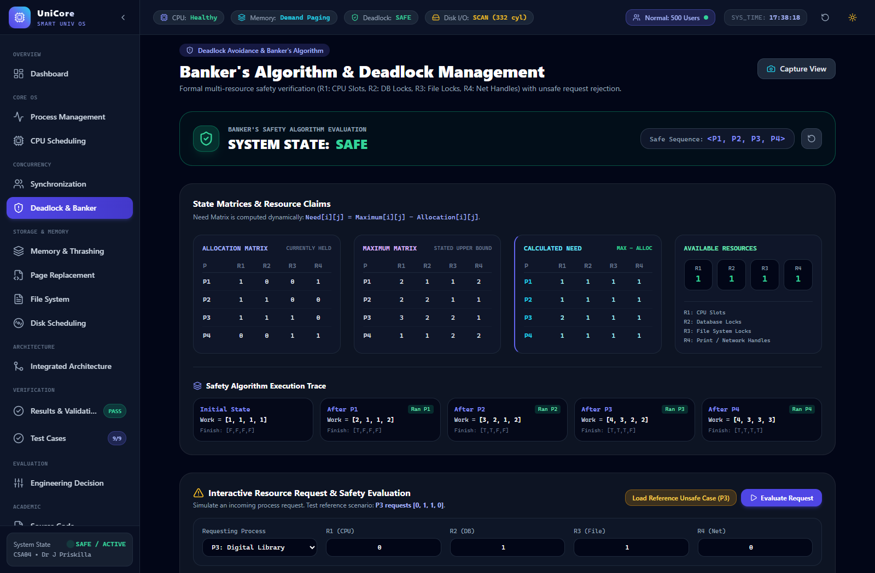
Figure D.6. Banker's Algorithm Safe State Verification – Resource Allocation, Maximum, Need matrices and safe sequence <P1, P2, P3, P4>.

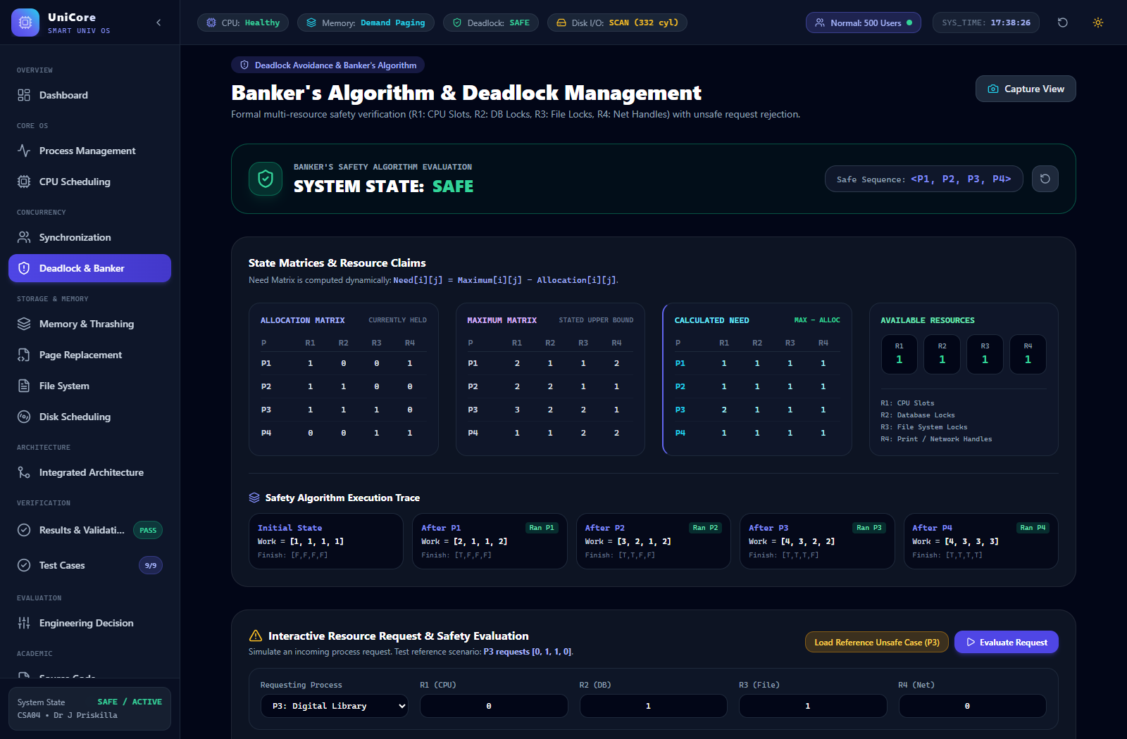
Figure D.7. Banker's Algorithm Adverse Unsafe Request – Rejection/postponement warning panel for process P3 requesting [0, 1, 1, 0].

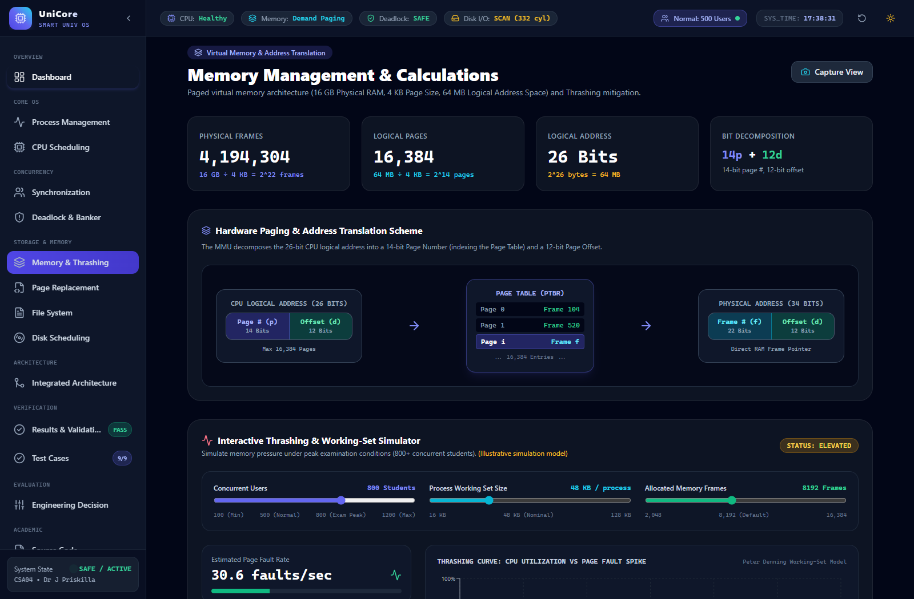
Figure D.8. Hardware Address Translation & Memory Calculation – Physical frame calculation (4,194,304 frames) and 26-bit logical address breakdown.

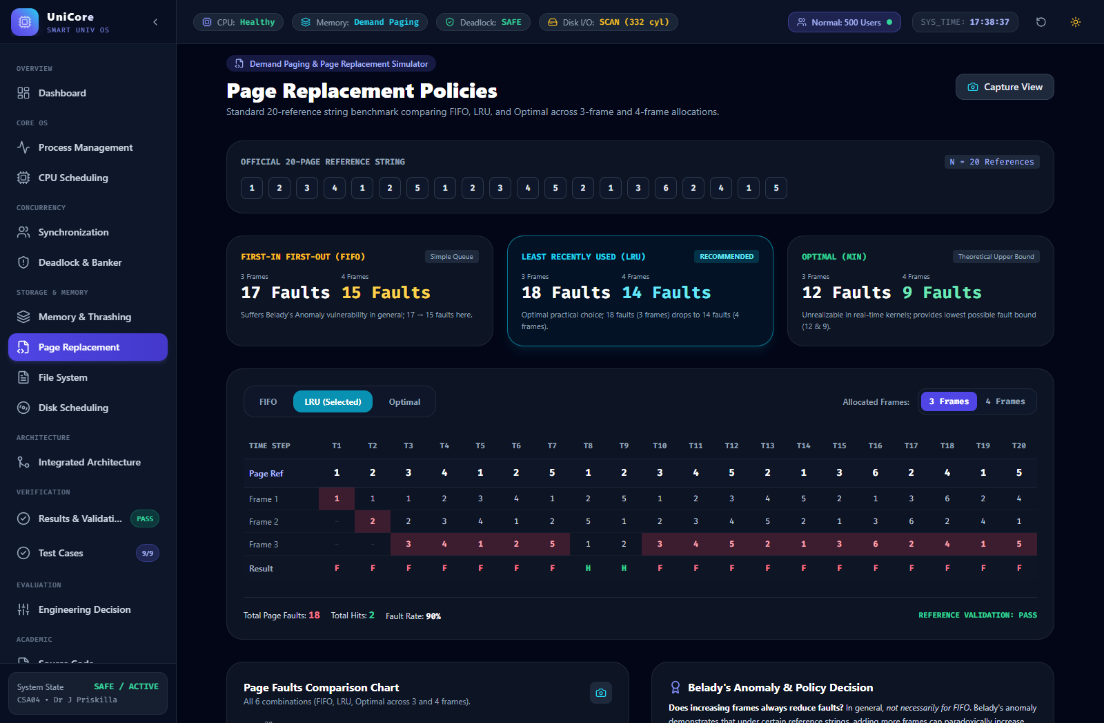
Figure D.9. First-In-First-Out (FIFO) Page Replacement – Frame-by-frame trace for 3 frames (17 faults) and 4 frames (15 faults).

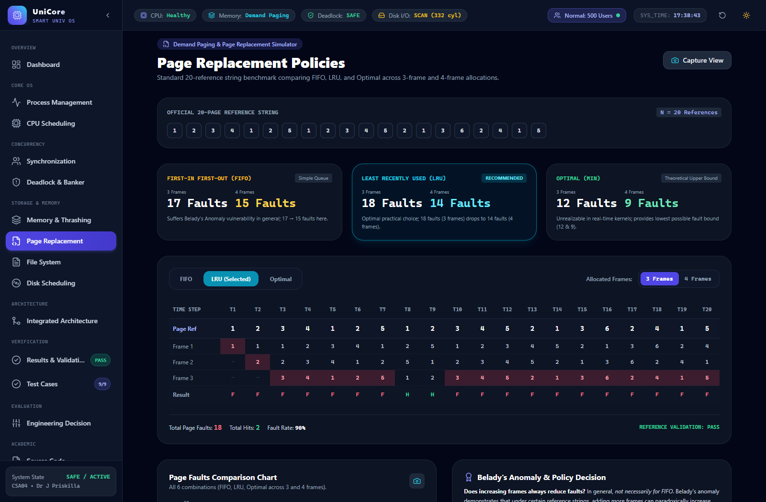
Figure D.10. Least Recently Used (LRU) Page Replacement – Frame-by-frame trace for 3 frames (18 faults) and 4 frames (14 faults).

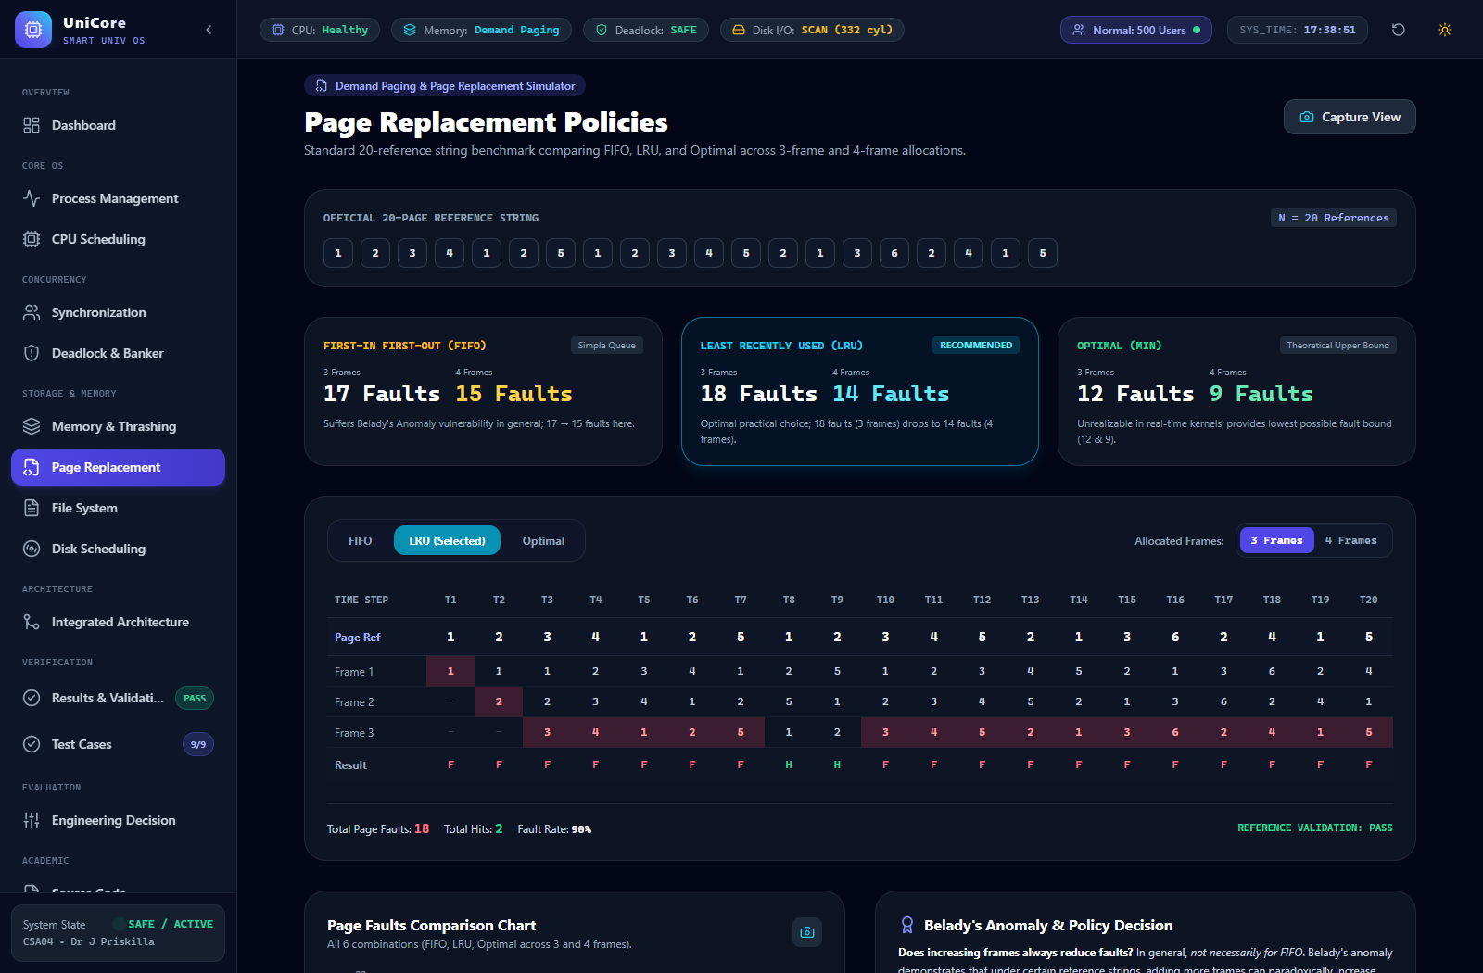
Figure D.11. Optimal Page Replacement (Belady's Min) – Theoretical benchmark trace for 3 frames (12 faults) and 4 frames (9 faults).


Figure D.12. Comparative Page Fault Analysis – Recharts comparison graph across FIFO, LRU, and Optimal policies.

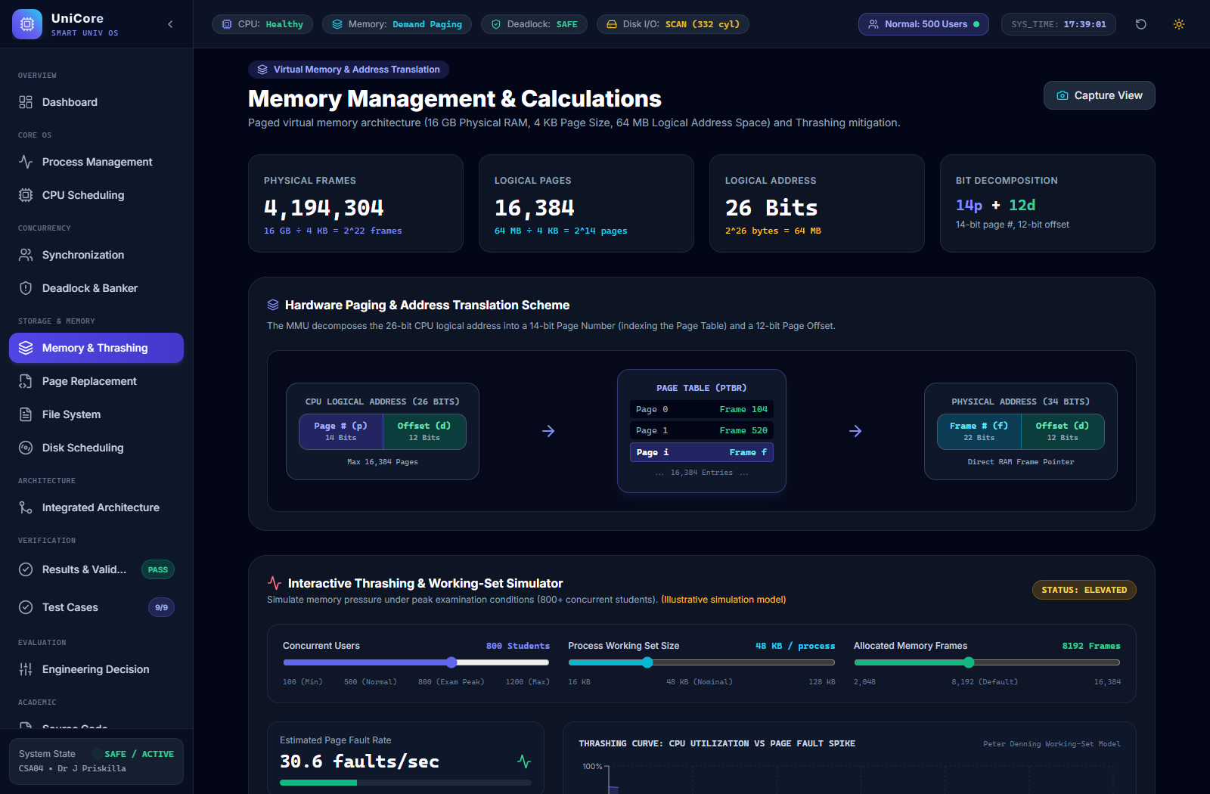
Figure D.13. Working-Set Thrashing Simulation – CPU utilization collapse and page fault rate explosion under 800+ user peak examination loads.

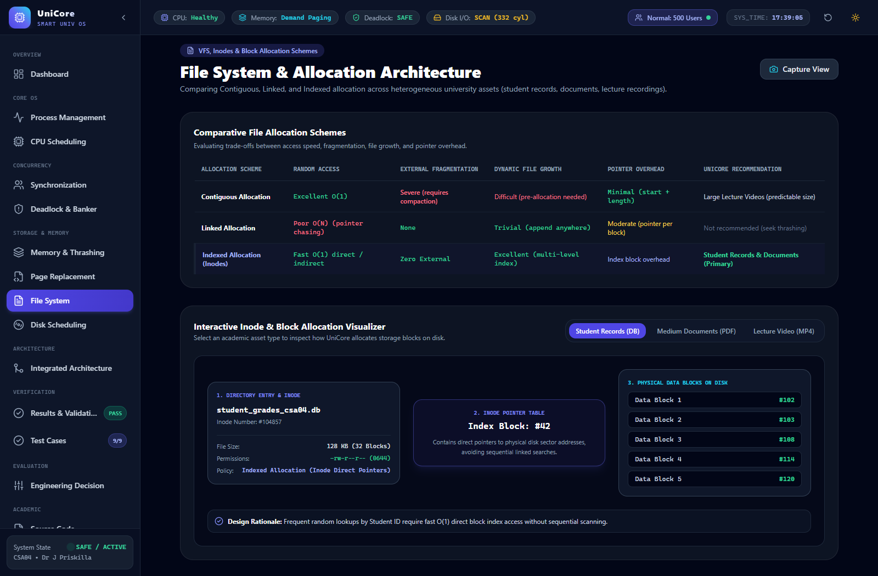
Figure D.14. File Allocation & Inode Directory Structure – Direct index block mapping for student databases and extents for lecture video streams.

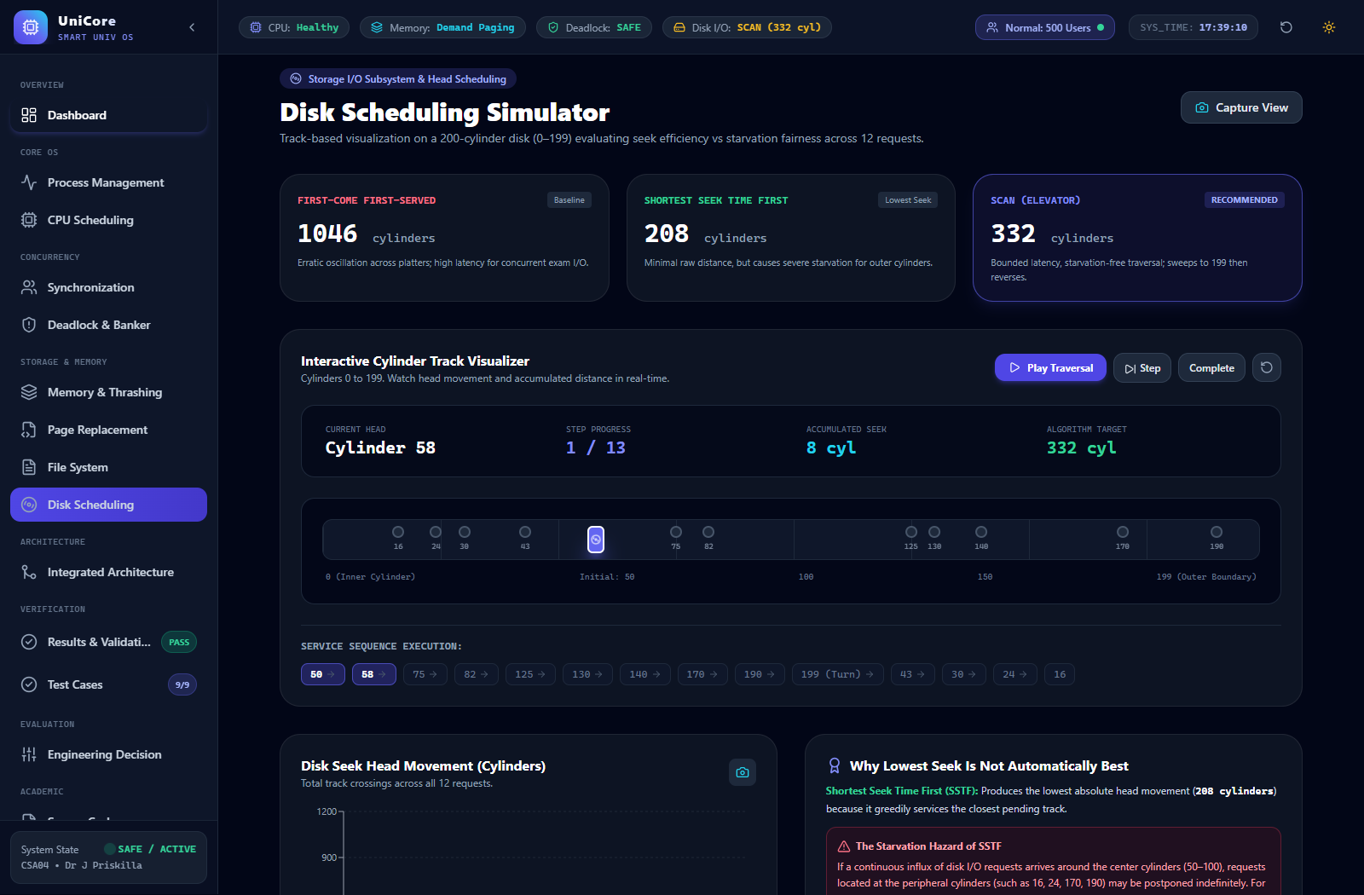
Figure D.15. FCFS Disk Head Scheduling – Sequential request service resulting in 1046 total cylinder movements.

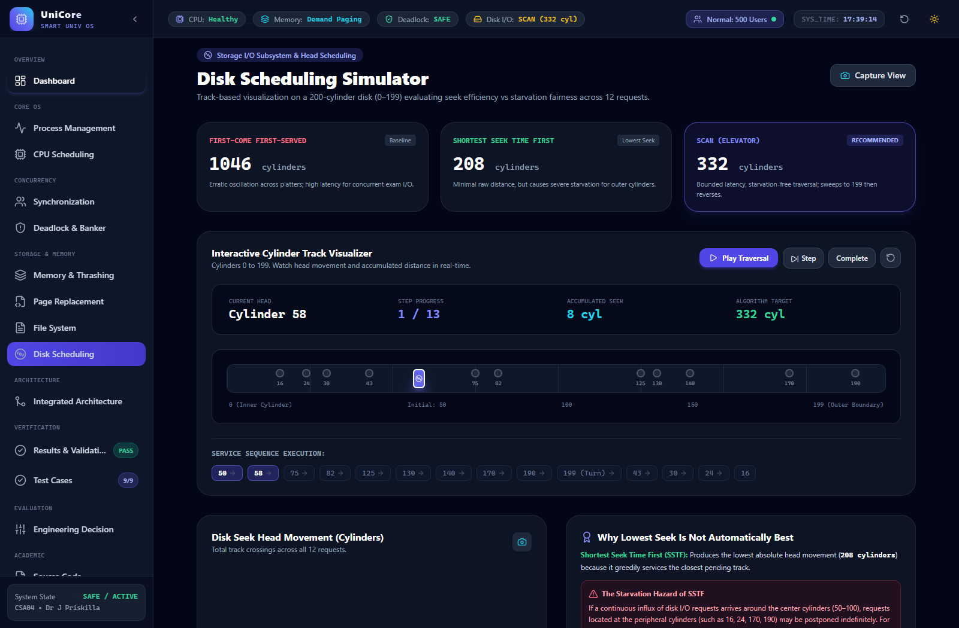
Figure D.16. Shortest Seek Time First (SSTF) Disk Scheduling – 208 cylinder movements with starvation demonstration on boundary cylinders.

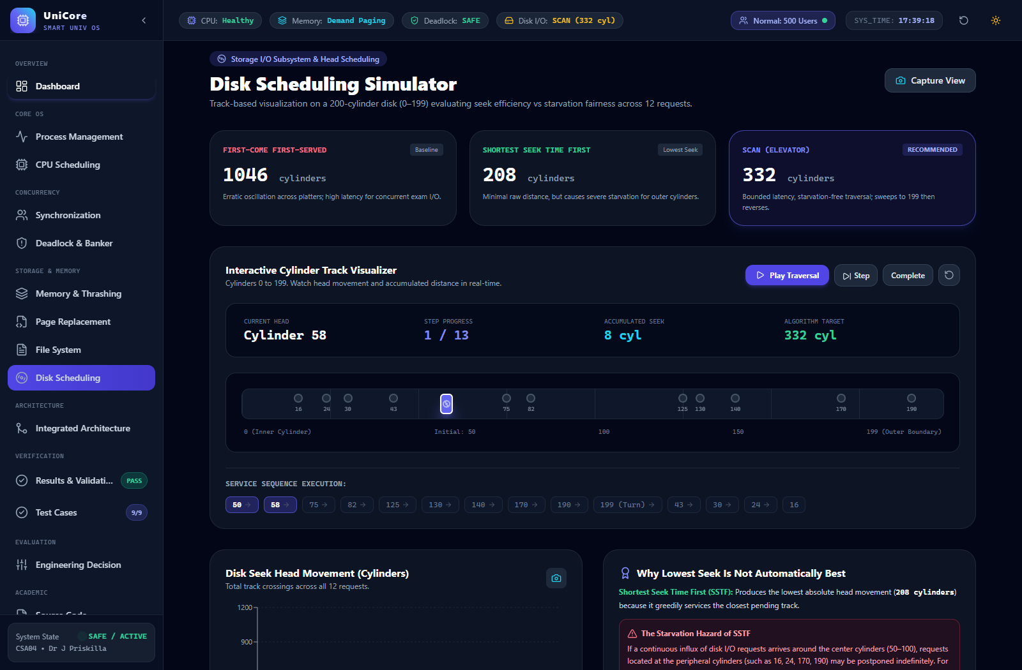
Figure D.17. SCAN (Elevator) Disk Scheduling Simulation – Starvation-free upward sweep to cylinder 199 resulting in 332 total cylinder movements.


Figure D.18. Comparative Disk Head Movement – Recharts seek distance comparison between FCFS, SSTF, and SCAN.


Figure D.19. UniCore Integrated System Architecture – Multi-layer operating system blueprint connecting university services to hardware.


Figure D.20. End-to-End User Request Lifecycle Flowchart – Decision pipeline from arrival through CPU, Banker's safety, Paging, and Disk I/O.

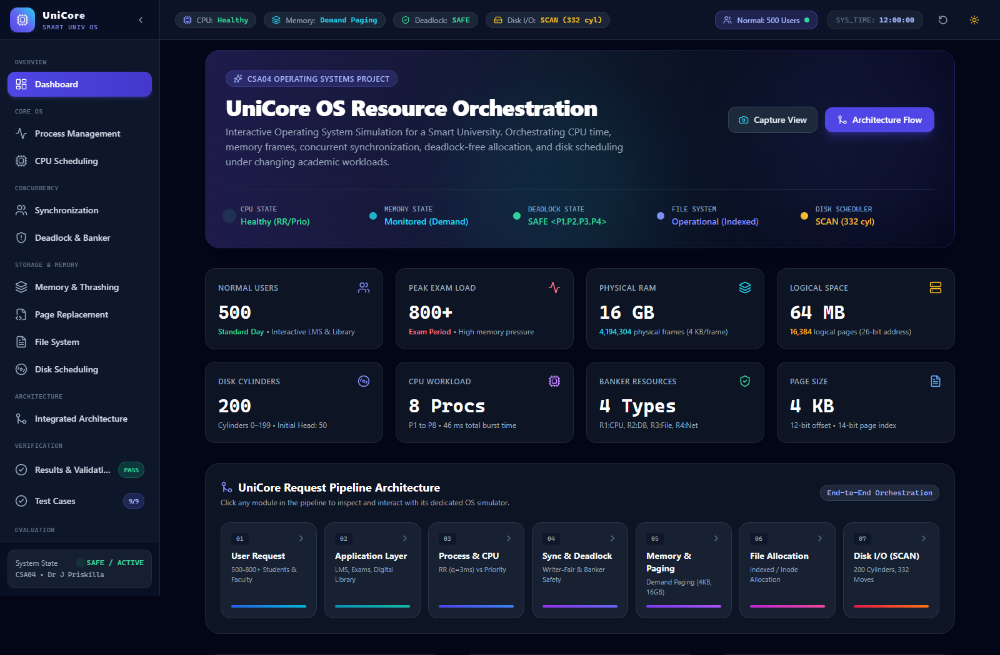
Figure D.21. Global Results & Validation Dashboard – Scorecard confirming 13/13 VERIFIED PASS benchmarks matching assignment standards.

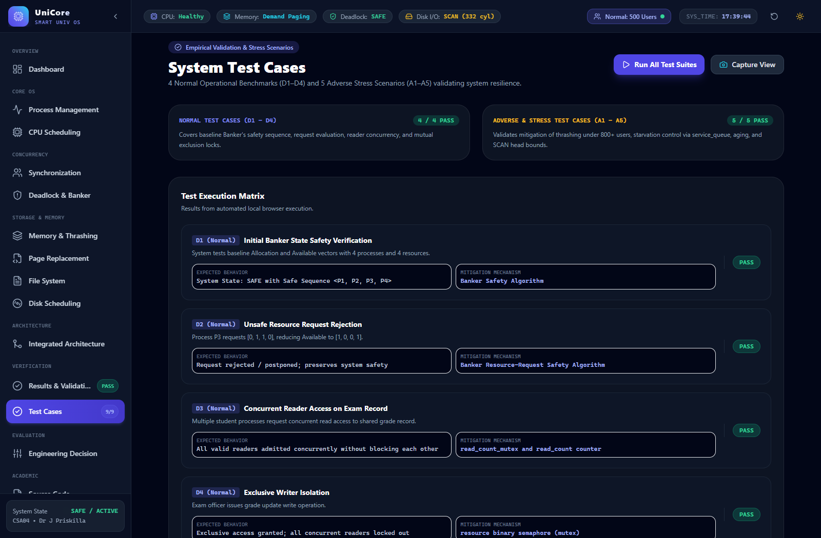
Figure D.22. Empirical Test Case Suite – Execution matrix for normal operation tests (D1-D4) and adverse stress scenarios (A1-A5).

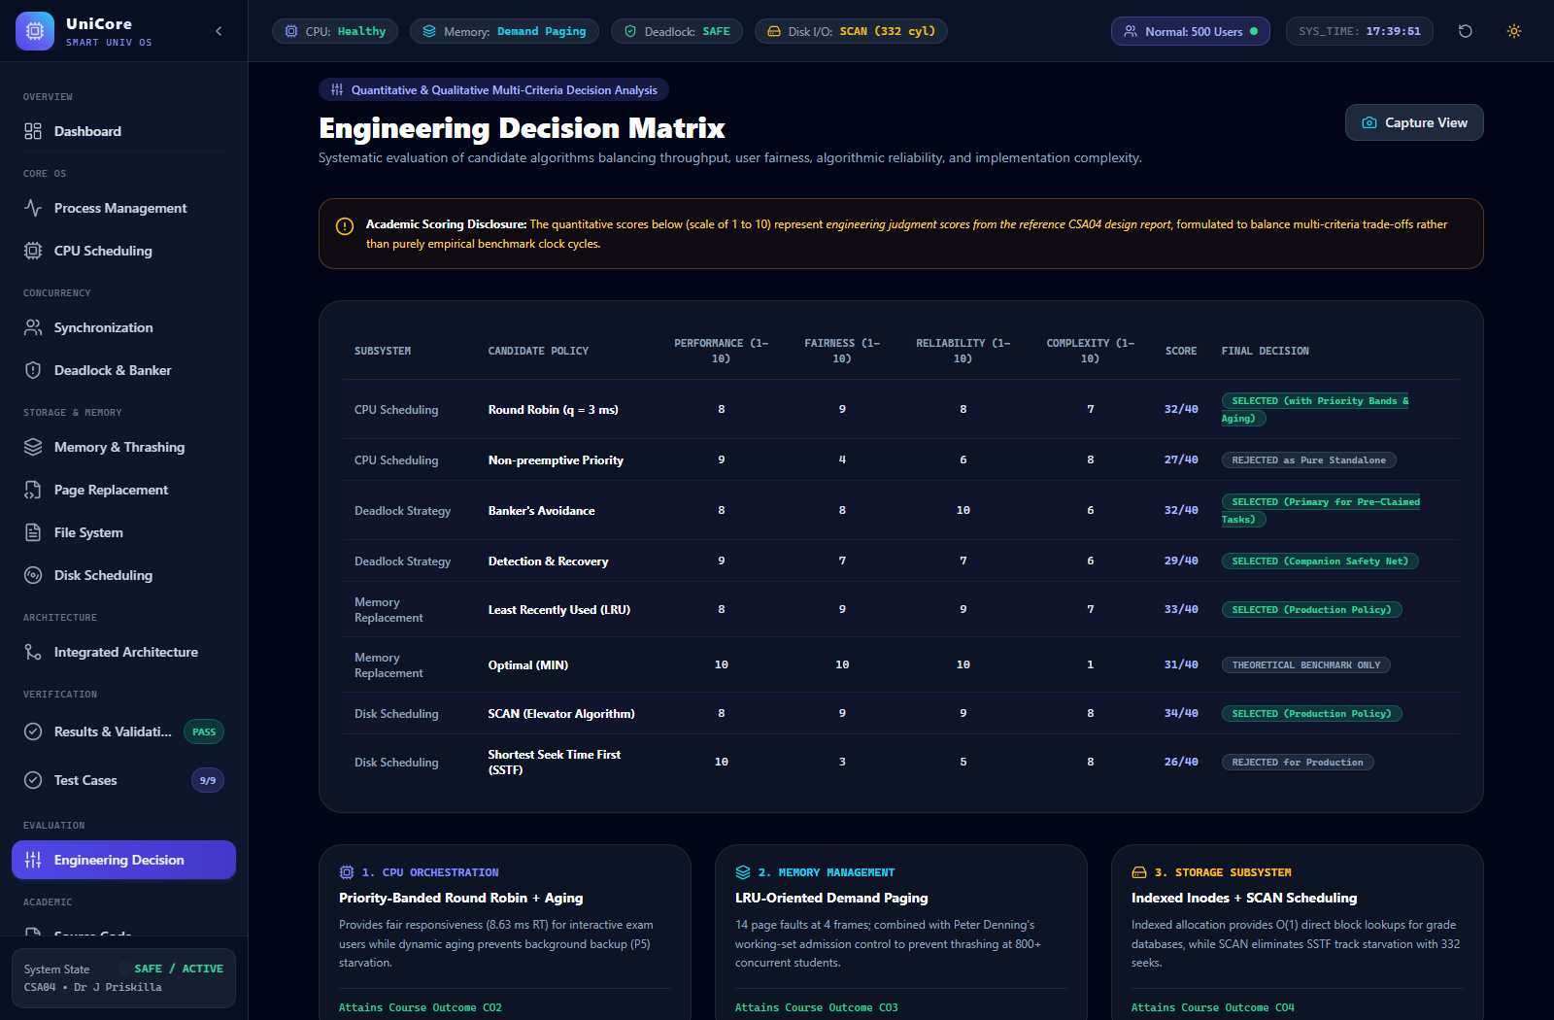
Figure D.23. Weighted Engineering Decision Matrix – Multi-criteria evaluation table balancing performance, fairness, and reliability.

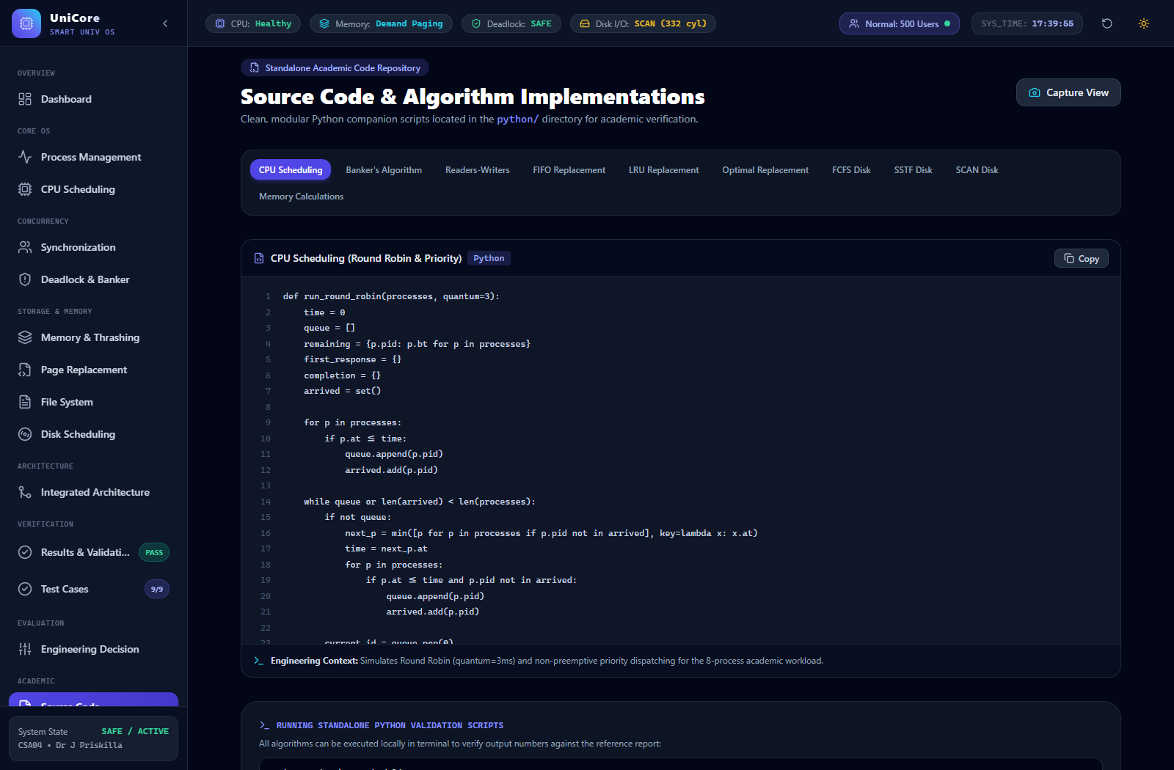
Figure D.24. Integrated Source Code Repository – Python validation scripts and algorithm implementations.

